FINANCIAL REPORTING AND FINANCIAL ANALYSIS USING POWER BI
- Profit and loss account
- Balance sheet
- Cash flow statement
- Statement of changes in equity
- Profitability ratio
- Liquidity ratio
- Risk management ratio
The dataset present in datasets folder, In GL, the territory key has information about territory which is a separate, all information related to territory not present here because we don’t wanna overpopulate that file.
Data model m table k kuch columns pr automatically kuch data categories select I hoti hn, e.g: kisi bhi date column ko pakro, us column k saath date ka icon bna ho ga, similarly, symmation ∑ ka icon aya hua hota h, agr index ya kisi or column k upper y symbol aya jisy hm sum nhi krna chahty, then data model k andr rehty huy hi select that column, go to properties (window present on left side), then go to advanced and data category m ja kr None kr do,, also some some categories when needed
- 1st we are calculating the amount generated by sales, ab jo aamount column m ammounts likhi hn bs unho ko hi sum nhi kr dena pakar kr, q k saari amount sales s generate nhi hui, chart_of_account table m jao or class, subclass, subclass2 m ja kr dekho to pta chly ga k sales k saath saath or kiittnii classes hn jin s amount mili ya gai
- Matrix m ja kr columns m just year daalny ki Bijay poori date ka column daal do to hierarchy create ho gi, yani arrows ay gy matrix k upper, jis s aap dril up ka dril down bhi kr skty to and hierarchy m upper neechy bhi ja skty ho to move to quarters, months, days etc etc . NOW we have 3 years, then hierarchy m neechy jany s we will move to quarters and it will give the sum of Quarter 1 of 2018+2019+2020, similarly for months: will give the sum of amount of all three years in each month,e.g for January: 2018 ki january, 2019 ki january, 2020 ki January ki amount, yani y teeno ammounts plus ho kr show ho gi January m, similarly for feb and so on, if we move further further to days, the esy hi teeno years ki un un days ko amount plus hogi and then show ho gi ,,, similarly we can drill down, yani if we have on years and we want just year 2020 ki hi quarters ki value, or phir in quarters k andr agy months ki value etc show hon to drill ko on kr k just us year pr click kr do and you will get quarters, then kisi ek quarter pr click kr do then you will get months of that quarter and so on
- Ab isi matrix ko select kr k line chart select kr do and you will get all that information in the form of graph, isi graph k legend m puri ki puri date daal do and click on ‘DATE HEIRARCHY’ from legend’s date dropdown and you will get all the information of three years altogether, like following:

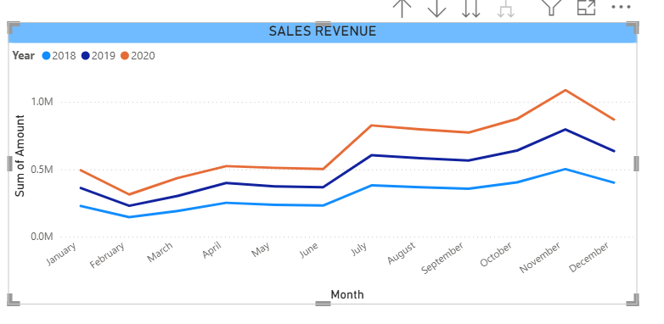

PROFIT AND LOSS STATEMENT:

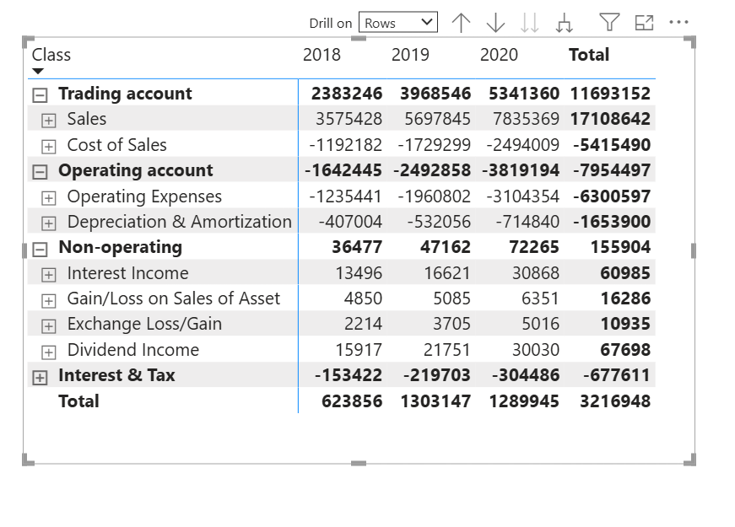
y just profilt and loss ka chart h, filter m ja kr just profit and loss select kia hua h, sab s phly sort to just top right corner k 3 dots pr kr k ho gya, then 2nd sort jo k sub-class k andr krna tha, us k liye jo y dropdown ka symbol sa a rha h "Class" column k uper us k zarye krna h, or is k liye class (e.g: trading account) k ander jo subclasses mention hn vo show hi rhi hon, yani class (e.g: trading account) k saath minus ka sign ho yani k y khula hua h, them Class column pr double click krna h, then y subclasses sort ho jayn gi, top right corner k 3 dots pr click kr k sort m ja kr check bhi kr lo k ab classes and subclasses dono sort hn
- Ab sales and cost of sales and all others have exact operators mention hn, sales k saath kuch nhi yani + and cose of sales k saath minus ka, to jab total kryn gy to hmy netprofit khud hi mil jay ga ,, yani exoenses already negative hn, we don’t need extra effort
- Add a slicer for each country and you will get the net profit with respect to each country

Until now: we have created profit and loss statement and now we will create net profit, gross profit, operating profit, profit before interest and tax.
Gross profit: revenue – cost of good sold
Yani jo revenue generate hua us m s just manufacturing cost (cost of making, cost of raw materials etc) minus kia just to vo gross profit mily ga,, ab TRADING ACCOUNT ki total amount ko dekhy to y actually gross proft hi h q k is m sales s jo amount mili us m s cost of sales ko minus kia hua h
End m jo overall amount hmy mil rhi h vo net profit h q k us m s taxes, labour cost, marketing cost (e.g: advertisement) etc etc sab ko minus kr k amount mili h
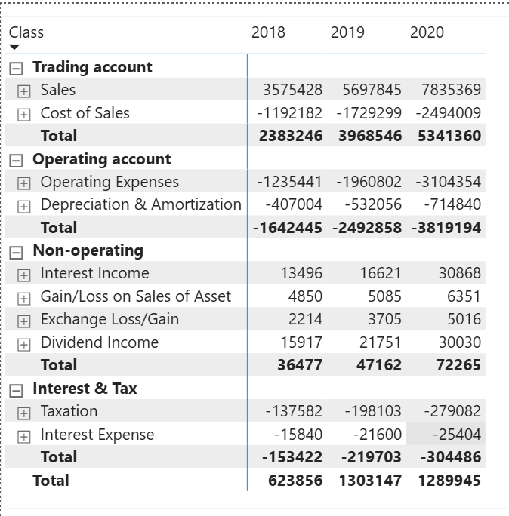
Now we want k isi matrix m hi TRADING ACCOUNT ki TOTAL amount h us ko rename kr k GROSS PROFIT kr dun and end valy total ko rename kr k NET PROFIT kr dun, but it is not possible here, so we will separately for each type of profit
DATASET m bhi CHART OF ACCOUNTS table m ja kr reports column m PROFIT AND LOSS h and agy class column m explain bhi kia hua h k kha kha s y profit ya loss a rha h, hmy yhan y idea ho ga k hm ki skis trah ka profit nikaal skty hn, yani TRADING ACCOUNT column k agy sales and cose of sales likha hua h, yhan s bhi pta lag rha h k hm gross profit nikal skty and we can calculate other profits as well, just focus of properly on dataset before starting.
Now we want k isi matrix m hi TRADING ACCOUNT ki TOTAL amount h us ko rename kr k GROSS PROFIT kr dun and end valy total ko rename kr k NET PROFIT kr dun, but it is not possible here, so we will separately for each type of profit
- GROSS PROFIT:
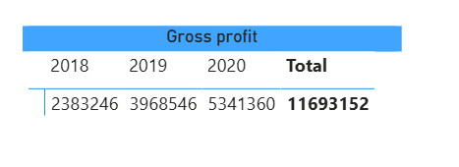
Simply create a matrix, values m amount daal di, column m year daal dia and filter m ja kr filter on this visual m ja kr CLASS column daal kr trading amount ko select kr dia, yani just trading amount ki value hi calulate honq k is k andr hmary pas (sales – cost of sales h)
- OPERATING PROFIT:
Now we will calculate operating profit, ab operating account m dekhy to just (expenses + Depreciation and amortization (y bhi expenses hi hn assets leny k )) hn, ab ofcourse esa to h nhi k hm in sab expenses ko plus kryn or khy k y hmara operating profit h (koi pagal hi ho ga jo esy kry ga), we will subtract all these expenses from our gross profit to get operating profit

Is k liye esa hi matrix bnay gy but filter m hm trading account and operating account dono ko daal den gy (yani in sab ki values ko plus kr do, ab sales vali value k andr s saary other values such as cost of sales and other expenses minus hon gy , yhan minus ka sign already lga hua h expenses k saath so we don’t need to have further calculation)

- PROFIT BEFORE TAX AND INTEREST (PBIT):
Now we will also add non-operating expenses in the filter and get values, ab saary expenses add ho chuky hn bs taxes rehty hn, to hm n is liye y heading use kr li, k saary expenses nikal kr jo hmy value mili and jo tax hm n dia, us s phly phly tk hmara y profit chal rhi thi

- Net profit:
Matalb revenue m s saary expenses and tax ko minus kr k jo amount mili

Revenue m s COGS (manufacturing cost, cost of raw materials etc) ko minus krny s GROSS PROFIT mila, gross profit m s just operating expenses ko minus krny s operating profit mila (operating profit also called EBIT yani EARNING BEFORE INTEREST AND TAX), is EBIT m s interest and tax and other non operating expenses minus krny s NET PROFIT mila
Operating expenses m amortization and depreciation or is k ilava kuch or expenses bhi aty hn,
Operating expenses m s A & D ko chor kr baki k expenses ko lets suppose hm X bolty hn,
gross profit m s just X ko nikal dia to hmy EBITDA (earning before interest, tax, depreciation and amortization) mila, yani EBITDA wo profit hai jisme abhi tak interest, tax, depreciation aur amortization and other non-operating expenses deduct nahi kiye gaye., yani EBITDA ki amount m s just A & D ki minus krny s hmy EBIT mily ga phir EBIT m s tax and interest and other non operating expenses ko minus krny s NET PROFIT mily ga
EBIT me operating expenses already deduct ho chuke hote hain, isi EBIT k peso k andr just Amortisation and Depreciation ko vapis daalny s hmy EBITDA mila (EBIT + A&D EBITDA), yani ab EBITDA k andr tax and interest and other non-operating expenses or amortization and depreciation k pesy mojood hn, y pesy deduct nhi kiye gay

Revenue – COGS = Gross Profit
Gross Profit – Operating Expenses (including D&A) = EBIT
EBIT – non-operating expenses (othr than interest and tax) = PBT (PBT m s abhi tk interst and tax k pesy deduct nhi huy huy)
PBT – Interest and Tax = Net profit (yani overall EBIT – Interest – Tax – other non-operating expenses = Net Profit)
OR
EBIT + D&A = EBITDA

Revenue – COGS = Gross Profit – Operating Expenses (including D&A) = EBIT ± Non-operating items = Profit Before Tax – Tax = Net Profit

PBT (profit before tax) m s sara kuch yani operating expenses and other non operating expenses nikly huy hn bs interest and tax nhi nikla hua, yani in peso m s bs interest and tax k pesy nikalny s hmy net profit mil jay ga

- Interest and tax is generally considered a part of non-operating expenses , but sometimes they can be different , yhan m n non operating ko interest and tas s almost different hi consider kia h

INTRODUCTON TO DAX HERE:
ROI (return on investment), Gross profit margin, net profit margin, return on capital employed calculated only using DAX.
If we wanna calculate gross profit margin, we will divide gross profit by sales, and there is no any way other than DAX to do that. With DAX, the opportunities become endless and we can anything we want
- GROSS PROFIT: use CALCULATE function to calculate gross profit using DAX and this is highly used function, almost 90% financial analysis made with this function:
gross_profit = CALCULATE(SUM(GL[Amount]),'Chart of Accounts'[Class]= "Trading account", 'Calendar'[Year] = 2019)

- PBIT = CALCULATE(SUM(GL[Amount]), 'Chart of Accounts'[Class] IN {"Trading account", "Operating account", "Non-operating"})
THE BEST WAY IS “IN”, because OR 2 s ziada conditions accept nhi krti. Efficient way IN h

- I have calculated net profit, gross profit, EBIT, EBITDA, PBIT etc etc using DAX, check out the formulaes from the analysis file, the fornulas are easy and staright forward.
NET PROFIT AND GROSS PROFIT MARGIN:
Net profit margin tells us how much profit a company earns from every $1 of sales.
For example, if the net profit margin is 20%, it means that out of every $100 of revenue, the company keeps $20 as profit after paying all expenses — including manufacturing cost, operating expenses, non-operating expenses, interest, and tax.
Similarly, gross profit margin tells us how much profit the company earns from its sales after deducting only COGS (Cost of Goods Sold).
For example, if the gross profit margin is 20%, it means that out of every $100 of revenue, $20 remains after covering manufacturing costs. This $20 is then used to cover operating expenses, interest, tax, etc.
What High and Low Margins Mean:
High net profit margin means:
Better cost control + Better pricing power + Efficient operations
Low net profit margin means:
High overall expenses or weak pricing
High gross profit margin means:
Lower manufacturing cost relative to selling price + Strong pricing power
Low gross profit margin means:
High manufacturing cost or product sold at a lower price due to competition
Working With FISCAL/FINANCIAL Year that is different from Calender Year:
Calender year start from January and ends at December, but financial year starts from July to 30th June and sometimes, it starts from april to 31st march, (depending on different countries, in eurape, financial and calender year are same, it start from January to December),
Means according to financial or fiscal year, the fiscal month of January is 7 (we are considering Pakistani fiscal/financial year that start from 1st July to 30th June)
To handle the calender year and fiscal year, we can do it in excel and in power BI as well, for POWER BI, we created a new file named DATE HANDLING , isi C drive k folder m hi ,,
DIFFERENCE BETWEEN CALENDER() AND CALENDERAUTO()
Calenderauto() s ek new table bny ga and is dataset m jitni bhi dates hn us ki base pr dates daali jayn gi, is table k dates couimn m, or is column m vo saari dates hon gi jo k us dataset m mojood hn,
But of there is no dataset, ya dataset m dates kisi bhi table m nhi hn to we can use CALENDER() function and manually pass dates like that: Table = CALENDAR(DATE(2018,01,01), DATE(2020, 01,01)),, This is calender year of course! You can give start months and end months and days according to financial year, but i am starting from scratch, this step can be different but remaining steps are same.

